 | 12.1.6 Editors - Geometry Node Editor - Header - Add Menu - Attribute
Table of content
Detailed table of content 1
Add menu 7
Attribute Capture 7
Attribute Statistics 8
Add menu - Legacy Nodes 9
Attribute Clamp 9
Attribute Color Ramp 10
Attribute Combine XYZ 12
Attribute Compare 13
Attribute Convert 14
Attribute Curve Map 16
Attribute Fill 18
Attribute Map Range 18
Attribute Math 19
Attribute Mix 20
Attribute Proximity 21
Attribute Randomize 22
Attribute Remove 23
Attribute Sample texture 24
Attribute Separate XYZ 25
Attribute Transfer 26
Attribute Vector Math 27
Attribute Vector Rotate 28

Detailed table of content
Detailed table of content
Detailed table of content 1
Add menu 7
Attribute Capture 7
Inputs 7
Geometry 7
Value 7
Properties 7
Domain Type 7
Outputs 7
Geometry 7
Attribute 8
Attribute Statistics 8
Inputs 8
Geometry 8
Attribute 8
Properties 8
Domain Type 8
Outputs 8
Mean 8
Median 8
Sum 8
Min 8
Max 8
Range 9
Standard Derivation 9
Variance 9
Add menu - Legacy Nodes 9
Attribute Clamp 9
Inputs 9
Geometry 9
Attribute 9
Result 9
Min 9
Max 9
Properties 9
Data Type 10
Outputs 10
Geometry 10
Attribute Color Ramp 10
Inputs 10
Geometry 10
Attribute 10
Result 10
Properties 10
Color Ramp 10
Controls 10
+ 10
- 10
Tools menu 11
Flip Color Ramp 11
Distribute Stops from Left 11
Distribute Stops Evenly 11
Eyedropper (pipette icon) E 11
Reset Color Ramp 11
Color Mode 11
RGB 11
HSV/HSL 11
Interpolation 11
Ease 11
Cardinal 11
Linear 11
B-Spline 11
Constant 11
Color Ramp 11
Active Color Stop elements 11
Choose active color stop 11
Pos 12
Outputs 12
Geometry 12
Attribute Combine XYZ 12
Inputs 12
Geometry 12
X / Y / Z 12
Result 12
Properties 12
Type X 12
Attribute 12
Float 12
Type Y 12
Attribute 13
Float 13
Type Z 13
Attribute 13
Float 13
Output 13
Geometry 13
Attribute Compare 13
Inputs 13
Geometry 13
A, B 13
Threshold 13
Result 13
Properties 14
Operation 14
A 14
B 14
Output 14
Geometry 14
Attribute Convert 14
Inputs 14
Geometry 14
Attribute 14
Result 15
Properties 15
Domain 15
Auto 15
Point 15
Edge 15
Face 15
Face Corner 15
Spline 15
Data Type 15
Output 15
Geometry 15
Attribute Curve Map 16
Inputs 16
Geometry 16
Attribute 16
Result 16
Properties 16
Data Type 16
Float 16
Vector 16
Color 16
Curve Widget 16
Navigation elements 16
Zoom in and out 16
Tools 17
Reset View 17
Vector Handle 17
Auto Handle 17
Auto Clamped Handle 17
Extend Horizontal 17
Extend Extrapolation 17
Reset Curve 17
Use Clipping 17
Delete Points 17
Curve window 17
X / Y values 17
Attribute Fill 18
Properties 18
Data Type 18
Inputs 18
Geometry 18
Attribute 18
Value 18
Output 18
Geometry 18
Attribute Map Range 18
Inputs 18
Geometry 18
Attribute 18
Result 18
From Min 19
From Max 19
To Min 19
To Max 19
Properties 19
Data Type 19
Outputs 19
Geometry 19
Attribute Math 19
Inputs 19
Geometry 19
Attribute A 19
Attribute B 19
Result 20
Properties 20
Operation 20
Type A 20
Attribute 20
Float 20
Type B 20
Attribute 20
Float 20
Output 20
Geometry 20
Attribute Mix 20
Inputs 20
Geometry 20
A 20
B 21
Result 21
Properties 21
Blending Mode 21
A 21
B 21
Output 21
Geometry 21
Attribute Proximity 21
Inputs 21
Geometry 21
Target 21
Result 22
Position 22
Properties 22
Target Geometry 22
Outputs 22
Geometry 22
Attribute Randomize 22
Inputs 22
Geometry 22
Attribute 22
Min 22
Max 22
Seed 22
Properties 23
Data Type 23
Float 23
Integer 23
Vector 23
Boolean 23
Operation 23
Outputs 23
Geometry 23
Attribute Remove 23
Inputs 23
Geometry 23
Attribute 23
Output 23
Geometry 23
Attribute Sample texture 24
Inputs 24
Geometry 24
Mapping 24
Result 24
Properties 24
Texture property 24
Texture Browser 24
Edit Box 24
Fake User 24
New Texture 24
Remove 24
Outputs 24
Geometry 24
Attribute Separate XYZ 25
Inputs 25
Geometry 25
Vector 25
Result X / Y / Z 25
Result 25
Properties 25
Type 25
Attribute 25
Float 25
Output 25
Geometry 25
Attribute Transfer 26
Inputs 26
Geometry 26
Source Geometry 26
Source 26
Destination 26
Properties 26
Domain 26
Auto 26
Point 26
Edge 26
Face 26
Face Corner 26
Spline 26
Mapping 27
Output 27
Geometry 27
Attribute Vector Math 27
Inputs 27
Geometry 27
A, B, C 27
Result 27
Properties 27
Operation 27
Type A 27
Type B 28
Output 28
Geometry 28
Attribute Vector Rotate 28
Inputs 28
Geometry 28
Vector 28
Center 28
Axis 28
Invert 28
Result 28
Properties 28
Mode 28
Input Type Vector 28
Input Type Center 29
Input Type Axis 29
Input Type Angle 29
Output 29
Geometry 29

Add menu

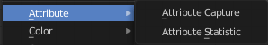
The Attribute menu contains the attribute nodes. These nodes allows you to work with object attributes.

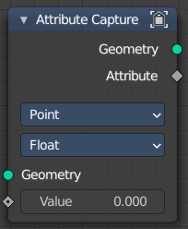
Attribute Capture
Capture an attribute from the input geometry.

Inputs

Geometry
Standard geometry input.

Value
Name of the attribute that is used as input. It should be a float attribute with values between zero and one.

Properties

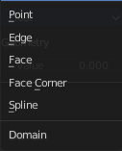
Domain Type
In which domain to store the data.

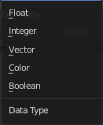
Data Type
What data type to use.

Outputs

Geometry
Standard geometry output.

Attribute
Attribute output.

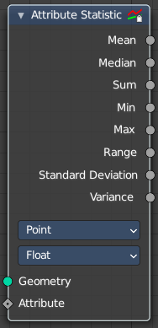
Attribute Statistics
Retreive statistic values from the input mesh.

Inputs

Geometry
Standard geometry input.

Attribute
Attribute input.

Properties

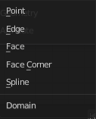
Domain Type
In which domain to store the data.

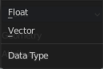
Data Type
What data type to use.

Outputs
Outputs the statistics for the different types.

Mean
Mean output statistics.

Median
Median output statistics.

Sum
Sum output statistics.

Min
Min output statistics.

Max
Max output statistics.

Range
Range output statistics.

Standard Derivation
Standard Derivation output statistics.

Variance
Variance output statistics.

Add menu - Legacy Nodes

These nodes existed in a former Bforartists version, but are now deprecated. They do not show in the regular menu or UI anymore. And you cannot insert them in a newer Bforartists version. But old projects that uses this nodes still loads with these nodes showing and enabled.

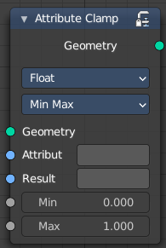
Attribute Clamp
Clamps the values of an attribute between a min and a max value

Inputs

Geometry
Standard geometry input.

Attribute
Name of the attribute that is used as input. It should be a float attribute with values between zero and one.

Result
Name of the attribute where the output is stored. If the attribute does not exist yet, it is created.

Min
The minimum value.

Max
The maximum value.

Properties

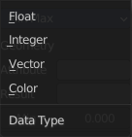
Data Type
What data type to clamp.

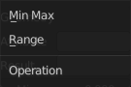
Operation
What clamp operation to use.

Outputs

Geometry
Standard geometry output.

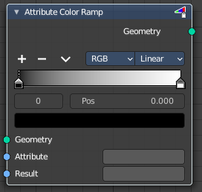
Attribute Color Ramp
Uses a color ramp ot map values from a float attribute to a color attribute of the target geometry.

Inputs

Geometry
Standard geometry input.

Attribute
Name of the attribute that is used as input. It should be a float attribute with values between zero and one.

Result
Name of the attribute where the output is stored. If the attribute does not exist yet, it is created.

Properties

Color Ramp
Color Ramps enables the user to specify a range of colors based on color stops. The color between the color stops gets interpolated.

Controls

+
Add a stop to your color ramp. The stop will be added after the selected one, in the middle to the next one.

-
Deletes the selected color stop from the list.


Tools menu

Flip Color Ramp
Flips the gradient, inverting the values of the color ramp.

Distribute Stops from Left
Rearrange the stops so that every step has the same space to the right.

Distribute Stops Evenly
Space between all neighboring stops becomes equal.

Eyedropper (pipette icon) E
An Eyedropper to sample a color or gradient from the interface to be used in the color ramp.

Reset Color Ramp

Resets the color ramp to its default state.

Color Mode

RGB
Blends color by mixing each color channel and combining.

HSV/HSL
Blends colors by first converting to HSV or HSL, mixing, then combining again. This has the advantage of maintaining saturation between different hues, where RGB would de-saturate, this allows for a richer gradient.


Interpolation

Ease
Uses an Ease Interpolation for the color stops.

Cardinal
Uses a Cardinal Interpolation for the color stops.

Linear
Uses a Linear Interpolation for the color stops.

B-Spline
Uses a B-Spline Interpolation for the color stops.

Constant
Uses a Constant Interpolation for the color stops.

Color Ramp
The color band. A click at one of the color stops makes it the active one. You can move the color stops by clicking at them and dragging them around.

Active Color Stop elements

Adjust the active color stop.

Choose active color stop
Choose the color stop by index.

Pos
The position of the active color stop. The range goes from 0.000 to 1.000

Outputs

Geometry
Standard geometry output.

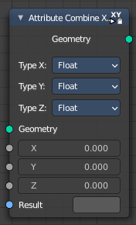
Attribute Combine XYZ
The Attribute Combine XYZ Node combines a vector attribute from its individual components.

Inputs

Geometry
Standard geometry input.

X / Y / Z
The single input components of the vector.

Result
Name of the attribute where the computed result it stored. If an attribute with this name does not exist yet, a new attribute with a Boolean data type is added. If it does exist, the values of the existing attribute are overridden.

Properties

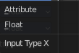
Type X
What type the X value of the vector is.

Attribute
The input is a text field that expects an attribute name.

Float
The input is a number field.

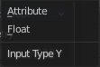
Type Y
What type the Y value of the vector is.

Attribute
The input is a text field that expects an attribute name.

Float
The input is a number field.

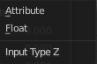
Type Z
What type the Z value of the vector is.

Attribute
The input is a text field that expects an attribute name.

Float
The input is a number field.

Output

Geometry
Standard geometry output.

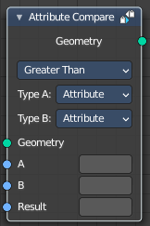
Attribute Compare
This node reads two input attributes as floats and allows for basic element-wise comparison operations. Like the Attribute Math node, it is also possible to switch to using single values for inputs. This node can be combined with the Point Separate node for more flexibility for which points to separate to the second output geometry.

Inputs

Geometry
Standard geometry input.

A, B
The first and second input to the math operation. Depending on the Type input, this is either an attribute name or an input of the specified data type.

Threshold
Shows with method Equal and Not Equal. This value is used as a threshold for still considering the two inputs as equal.

Result
Name of the attribute where the computed result it stored. If an attribute with this name does not exist yet, a new attribute with a Boolean data type is added. If it does exist, the values of the existing attribute are overridden.

Properties

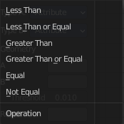
Operation
The math function to use.
Note! For operations besides Equal and Not Equal, the input attributes are converted implicitly to the float data type. For the equality operations on vectors, the distance between the vector inputs is used.

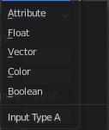
A
Input type A for the corresponding socket.

B
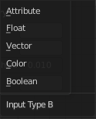
Input type B for the corresponding socket.

Output

Geometry
Standard geometry output.

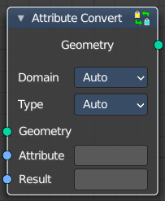
Attribute Convert
Reads one input attribute and converts the data type and domain to the result attribute. The data type conversion is determined by a set of built-in implicit conversion rules. These rules are also used when connecting sockets with different data types. Additional information can be found in the Node Socket section of the manual.
Note that the data conversion rules are not editable. When converting a vector to a float, the implicit rule may not be desired. In this case it is recommended to use Attribute Math nodes together with Attribute Combine and Attribute Separate nodes to achieve the desired result.

Inputs

Geometry
Standard geometry input.

Attribute
Name of the attribute that is to be converted.

Result
Name of the attribute where the computed result it stored. If an attribute with this name does not exist yet, a new attribute is added. If it does exist, the values of the attribute are overridden.

Properties

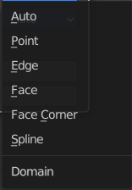
Domain
What domain to use to save the result attribute. Where the source attribute resides on a different domain, the data is interpolated.

Auto
Chooses the domain based on the following rules.
If the result attribute already exists, use that domain. If the result attribute doesn’t exist, use the source attribute domain. Otherwise use the default domain (points).

Point
Store the resulting attribute per point.

Edge
Store the resulting attribute per edge.

Face
Store the resulting attribute per face.

Face Corner
Store the resulting attribute per face corner.

Spline
Store the resulting attribute per spline.

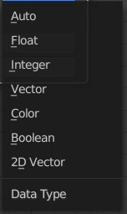
Data Type
The data type of the result attribute.

Output

Geometry
Standard geometry output.

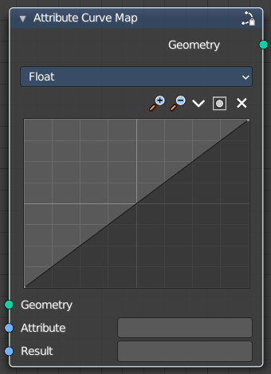
Attribute Curve Map
Lets you map an attribute through a curves panel.

Inputs

Geometry
Standard geometry input.

Attribute
Name of the attribute that is to be converted.

Result
Name of the attribute where the computed result it stored. If an attribute with this name does not exist yet, a new attribute is added. If it does exist, the values of the attribute are overridden.

Properties

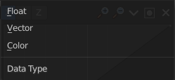
Data Type
What data type to work with.

Float
Work with float values.

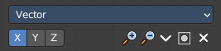
Vector
Work with Vector 3 values. You can choose which value of the vector to use. X, Y or Z.

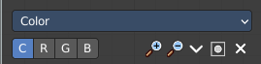
Color
Work with color values. You can choose which value of the color to use.

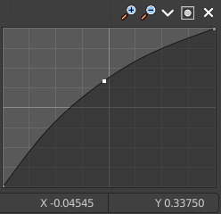
Curve Widget

Navigation elements
The navigation elements at the top are described from left to right.

Zoom in and out
The two buttons with the magnifying glass at it zooms in and out in the curve window.

Tools
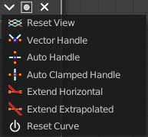
Tools is a menu where you can find some curve related tools.

Reset View
Resets the curve windows zoom.

Vector Handle
Set handle type to Vector.

Auto Handle
Set handle type to Auto.

Auto Clamped Handle
Set handle type to Auto Clamped.

Extend Horizontal
Extends the curve before the last point and after the last point horizontally.

Extend Extrapolation
Extends the curve before the last point and after the last point extrapolated.

Reset Curve
Resets the curve to the initial shape.


Use Clipping
Clipping options. Set up clipping for the stroke.

Delete Points
Deletes selected curve point.

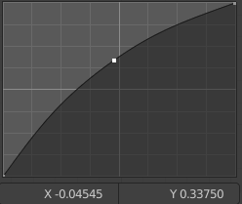
Curve window
Tweak and adjust the falloff curve by clicking at a curve point and dragging it around.
Double click adds a new point.
Holding down ctrl activates temporary snapping.
Holding down shift enables slower movement, which allows more accurate setting.

X / Y values
The x and y value of the currently selected point.

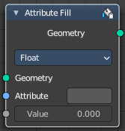
Attribute Fill
The Attribute Fill node sets the value for every element of the attribute with the input name to the input value. If the attribute doesn’t exist yet, it will be created.

Properties

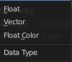
Data Type
The type of data to fill the attribute with.

Inputs

Geometry
The geometry that is modified.

Attribute
The name of the attribute to fill with the value.

Value
A value of the data type to fill the attribute with.

Output

Geometry
The same geometry as the input with a modified attribute.

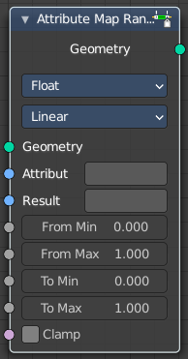
Attribute Map Range
Clamps the values of an attribute between a min and a max value range.

Inputs

Geometry
Standard geometry input.

Attribute
Name of the attribute that is used as input. It should be a float attribute with values between zero and one.

Result
Name of the attribute where the output is stored. If the attribute does not exist yet, it is created.

From Min
The lowest minimum value.

From Max
The highest minimum value.

To Min
The lowest maximum value.

To Max
The highest maximum value.

Properties

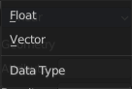
Data Type
What data type to clamp.

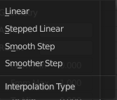
Interpolation type
What interpolation type to use.

Outputs

Geometry
Standard geometry output.

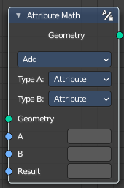
Attribute Math
Modify an attribute with a math operation.

Inputs

Geometry
Standard geometry input.

Attribute A
The first input to the math operation. This can be either an attribute name or numeric value.

Attribute B
The second input to the math operation. This can be either an attribute name or numeric value.

Result
Name of the attribute where the computed result it stored. A new attribute with that name is added, if it does not exist yet. If it does exist, the existing attribute is overridden.

Properties

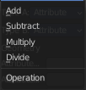
Operation
The math function to perform.
Note! Attributes are converted implicitly to the float data type.

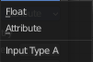
Type A

Attribute
The input is a text field that expects an attribute name.

Float
The input is a number field.

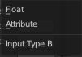
Type B

Attribute
The input is a text field that expects an attribute name.

Float
The input is a number field.

Output

Geometry
Standard geometry output.

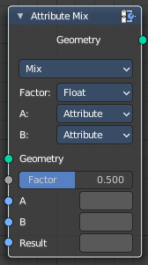
Attribute Mix
Mix attributes to creates to create a new attribute.

Inputs

Geometry
Standard geometry input.

A
The first input to the mix operation. This can be an attribute name or a value.
Result

B
The second input to the mix operation. This can be an attribute name or a value.

Result
Name of the attribute where the computed result is stored. The output attribute type is Color by default. When the result attribute exists already, its type is not changed.

Properties

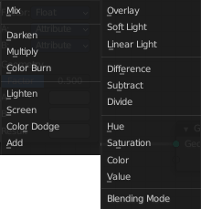
Blending Mode
Operation that is performed on the inputs.

A
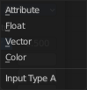
Input type A for the corresponding socket.

B
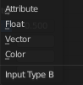
Input type B for the corresponding socket.

Output

Geometry
Standard geometry output.

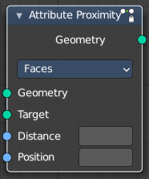
Attribute Proximity
This node finds the closest position on the target for each point in the input geometry.
Both, position and distance to them can be stored in attributes.

Inputs

Geometry
Standard geometry input.

Target
Name of the attribute to fill with random values. If there is no attribute with the given name, a new one is created.

Result
Name of the attribute where the output is stored. If the attribute does not exist yet, it is created.

Position
The name of the attribute where the computed location is stored.
A new attribute with that name is added if it does not exist yet. If it does exist, the values of the existing attribute are overridden.

Properties

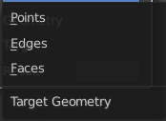
Target Geometry
The element of the target geometry to calculate the distance from.

Outputs

Geometry
Standard geometry output.

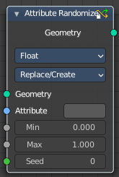
Attribute Randomize
The Attribute Randomize node replaces the values in an attribute with random values within the given range.

Inputs

Geometry
Standard geometry input.

Attribute
Name of the attribute to fill with random values. If there is no attribute with the given name, a new one is created.

Min
The random value will be at least those values.

Max
The random values will be no more than those values.

Seed
Seed to change the random sequence.

Properties

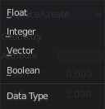
Data Type
Type of data stored in the attribute.

Float
Single (floating-point) value.

Integer
A integer value.

Vector
Array of three (floating-point) values.

Boolean
A true or false value.

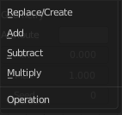
Operation
What operation method to use.

Outputs

Geometry
Standard geometry output.

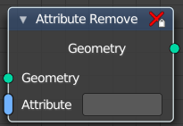
Attribute Remove
For more complicated node setups you can often accumulate many temporary attributes. This node is able to remove them.

Inputs

Geometry
Standard geometry input.

Attribute
The attribute that you want to remove.

Output

Geometry
Standard geometry output.

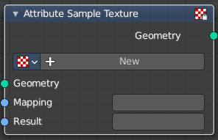
Attribute Sample texture
The Attribute Sample Texture node evaluates a texture for every point, and stores the resulting colors in a new attribute. The mapping attribute can be anything that can be converted to a 3D vector. For example the name of a uv map or the position attribute is used.
Note that UV maps can only be accessed after a Point Distribute node currently. This is a limitation that will be resolved.

Inputs

Geometry
Standard geometry input.

Mapping
Name of the attribute that is used as input. It should be a float attribute with values between zero and one.

Result
Name of the attribute where the output is stored. If the attribute does not exist yet, it is created.

Properties

Texture property

The texture to use.

Texture Browser
A list of the available textures.

Edit Box
The name of the current active texture. Click to edit.

Fake User
Assign a fake user to this texture so that it is not removed when closing Bforartists.

New Texture
Add a new texture.

Remove
Remove the texture. This sets the texture inactive. It is still in the texture list.

Outputs

Geometry
Standard geometry output.

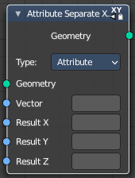
Attribute Separate XYZ
The Attribute Separate XYZ Node separates a vector attribute into its individual components.

Inputs

Geometry
Standard geometry input.

Vector
Attribute Vector input

Result X / Y / Z
The single input components of a vector.

Result
Name of the attribute where the computed result it stored. If an attribute with this name does not exist yet, a new attribute with a Boolean data type is added. If it does exist, the values of the existing attribute are overridden.

Properties

Type
What type the value of the vector is.

Attribute
The input is a text field that expects an attribute name.

Float
The input is a number field.

Output

Geometry
Standard geometry output.

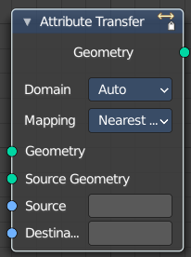
Attribute Transfer
Transfers several types of data from one mesh to another. Data types include vertex groups, UV maps, vertex colors, and custom normals.

Inputs

Geometry
Standard geometry input.

Source Geometry
Source geometry input.

Source
Source attribute

Destination
Destination attribute.

Properties

Domain
What domain to use to save the result attribute. Where the source attribute resides on a different domain, the data is interpolated.

Auto
Chooses the domain based on the following rules.
If the result attribute already exists, use that domain. If the result attribute doesn’t exist, use the source attribute domain. Otherwise use the default domain (points).

Point
Store the resulting attribute per point.

Edge
Store the resulting attribute per edge.

Face
Store the resulting attribute per face.

Face Corner
Store the resulting attribute per face corner.

Spline
Store the resulting attribute per spline.

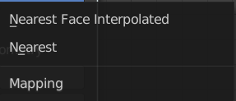
Mapping
How to map the data.

Output

Geometry
Standard geometry output.

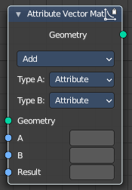
Attribute Vector Math
Modify an attribute with a math operation.

Inputs

Geometry
Standard geometry input.

A, B, C
The inputs to the math operations. Depending on the operation one, two, or all three of the inputs will be used. The attribute types are all vectors of three values, except for the Scale operation, where the second input uses a float type.

Result
The name of the attribute where the computed result it stored. A new attribute with that name is added if it does not exist yet. If it does exist, the values of the existing attribute are overridden.

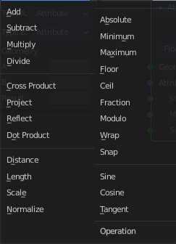
Properties

Operation
The available vector math operations. The methods should be self explaining.
Note that attributes are converted implicitly to the input data type.

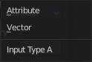
Type A
Input type A for the corresponding socket.

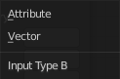
Type B
Input type B for the corresponding socket.

Output

Geometry
Standard geometry output.

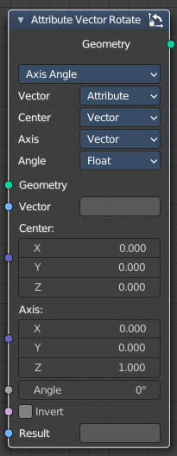
Attribute Vector Rotate
Rotates the vector values.

Inputs

Geometry
Standard geometry input.

Vector
The attribute name of the vector.

Center
The center of the vector

Axis
The axis orientation and rotation of the vector.

Invert
Invert the vector values.

Result
The name of the attribute where the computed result it stored. A new attribute with that name is added if it does not exist yet. If it does exist, the values of the existing attribute are overridden.

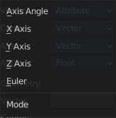
Properties

Mode
How to modify the vector values.

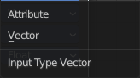
Input Type Vector
The input type.

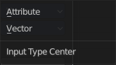
Input Type Center
The center type.

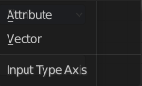
Input Type Axis
The axis type.

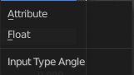
Input Type Angle
The angle type.

Output

Geometry
Standard geometry output.

